**Huawei Mobile Development**

In August 2019, the Chinese tech giant Huawei officially announced its unified operating system: HarmonyOS (as a replacement for android). Due to the US restrictions, the company decided to work on its own platform for Huawei devices.

With Huawei Mobile Services, the company offers its own competing platform that replaces the Google Mobile Services (collection of APIs and all your favorite Google apps, including Google Maps, Google Drive, YouTube, Google Photos, Google Play Store, Google Chrome) in Huawei devices.

It started off with IoT devices such as smart home equipment, then moved on to TVs. The OS is now coming to phones, tablets, and smartwatches as well.

Huawei devices sold before 16 May 2019 would continue to receive Android updates. However, this license expired on 13 August 2020, and as it appears that it will not receive any more extensions, Huawei smartphone users were left with questions about the fate of their phones.

Till Huawei phone, the P30 Pro - Google services are supported

**HarmonyOS 2.0** launched at the Huawei Developer Conference on 10 September 2020. Huawei announced it intended to ship the operating system on its smartphones in 2021. The first developer beta of HarmonyOS 2.0 was launched on 16 December 2020.

The focus on HarmonyOS working across devices is one-way Huawei is trying to differentiate its operating system from Google’s Android and Apple’s iOS.

Basically if we want to work for Huawei mobile development so we need HMS for android and that can be done in 2 ways –  
- Integrating the HMS Core SDK with Android Studio  
- Integrating HMS Plugin to Cordova Project

Integrating the HMS Core SDK with Android Studio

* Android Studio installation - RITM0093412 - [REQ0086936](https://ind01.safelinks.protection.outlook.com/?url=https%3A%2F%2Fyashinmsp.service-now.com%2Fnav_to.do%3Furi%3Dsc_request.do%253Fsys_id%3Db4ac92b61b5f0110c59e4377cc4bcba6%2526sysparm_stack%3Dsc_request_list.do%253Fsysparm_query%3Dactive%3Dtrue&data=05%7C01%7Cmujeeba.khan%40yash.com%7Cbe4132b68d7e4d1b7d7608da32686019%7C2161a74d1c3e4d34a8c8131360d2e92c%7C1%7C0%7C637877721109604014%7CUnknown%7CTWFpbGZsb3d8eyJWIjoiMC4wLjAwMDAiLCJQIjoiV2luMzIiLCJBTiI6Ik1haWwiLCJXVCI6Mn0%3D%7C3000%7C%7C%7C&sdata=lQ%2Fp6rhnqzMC4EhMcbu7%2FvDjTeX9Yw%2BTmJdu84xOjSo%3D&reserved=0) – in progress
* RAM upgradation - RITM0093418 - REQ0086942 – in progress
* [Adding the AppGallery Connect Configuration File of Your App](https://developer.huawei.com/consumer/en/doc/#section16508174519446)
  + Registering as a Developer
    - Sign up - done
    - Identity verification – done
  + [Creating an App](https://developer.huawei.com/consumer/en/doc/distribution/app/agc-help-createapp-0000001146718717) – at AppGallery Connect - done

Creating an App –

Developer information

Developer Id – 10091000026348325

Public key - 

Project information

Project name: Huawei\_Demo

Project ID: 99536292102263607

Client information

Client ID 888916237537526848

Client secret 13E621233C7D86F31DDC981610FFD9FAA0536985597FBC10B953966671E372BC

API key DAEDALIQUxLCxmJNbkclLVkItiZAa/Y9EJuKsgvWmKi8lLxe1pjeBordzUHMCQbI9SKQjplXl+qpjS4cvU8QI9kyd1arBHaaIsARLA==

App information

App name : AGCFirstApp

Top of Form

Created: 2022-05-11 11:33:58

Package name: com.AGCFirstApp.huawei

Package type: APK

App ID: 106190299

Bottom of Form

Top of Form

Devices supported: Mobile phone

Bottom of Form

* + Generating a Signing Certificate Fingerprint – waiting for Android studio

Path - D:\keystore\upload-keystore.jks

Pass – huaweiapp

Key alias – uploadkey

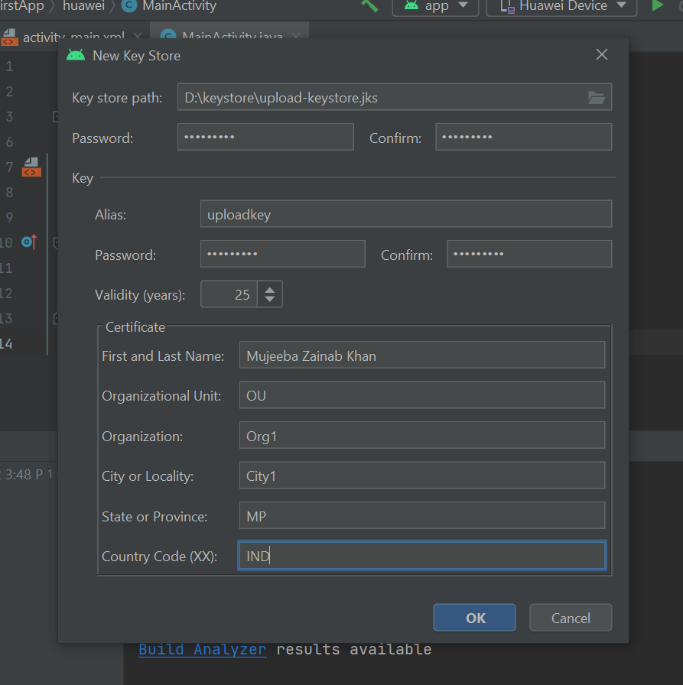

* [Configuring the Maven Repository Address for the HMS Core SDK](https://developer.huawei.com/consumer/en/doc/#section56121205458)
* [Adding Build Dependencies](https://developer.huawei.com/consumer/en/doc/#section1499291613157)
* [Defining Multi-language Settings](https://developer.huawei.com/consumer/en/doc/#section176651227194912)
* [Synchronizing the Project](https://developer.huawei.com/consumer/en/doc/#section757255813578)

Downloading agconnect-services.json file-

1. Sign in to [AppGallery Connect](https://developer.huawei.com/consumer/en/service/josp/agc/index.html" \t "_blank) and click **My projects**.
2. Click your project card.
3. Go to **Project settings** > **General information**. In the **App information** area, click **agconnect-services.json** to download the file.